5. ReactJS-HOL

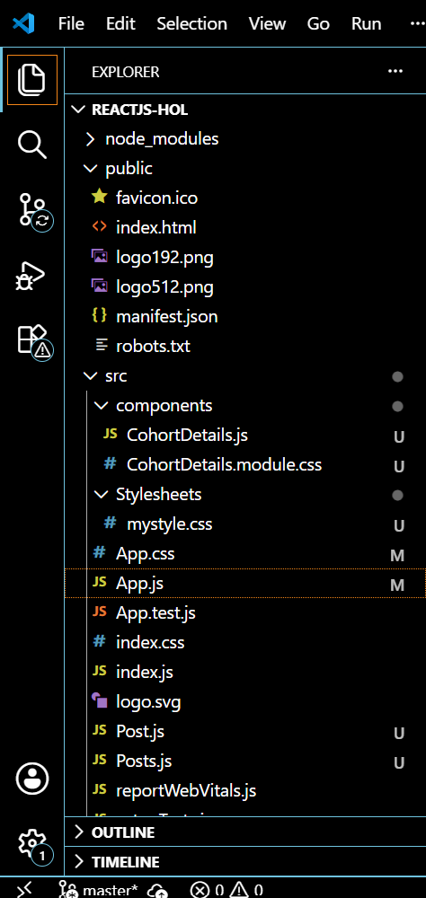

index.js
import React from 'react';
import ReactDOM from 'react-dom/client';
import App from './App';
import './index.css';

const root = ReactDOM.createRoot(document.getElementById('root'));
root.render(
<React.StrictMode>
<App />
</React.StrictMode>
);

App.js
import React from 'react';
import CohortDetails from './components/CohortDetails';

function App() {
return (
<div className="App">
<CohortDetails />
</div>
);
}

export default App;

CohortDetails.js
import React from 'react';
import styles from './CohortDetails.module.css';

const cohortData = [
{
name: 'INTADMFD10 - .NET FSD',
startDate: '22-Feb-2022',
status: 'Scheduled',
coach: 'Aathma',
trainer: 'Jojo Jose'
},
{
name: 'ADM21JF014 - Java FSD',
startDate: '10-Sep-2021',
status: 'Ongoing',
coach: 'Apoorv',
trainer: 'Elisa Smith'
},
{
name: 'CDBJF21025 - Java FSD',
startDate: '24-Dec-2021',
status: 'Ongoing',
coach: 'Aathma',
trainer: 'John Doe'
}
];

const CohortDetails = () => {
return (
<div style={{ padding: '20px' }}>
<h2>Cohorts Details</h2>
{cohortData.map((cohort, index) => (
<div key={index} className={styles.box}>
<h3
style={{
color: cohort.status.toLowerCase() === 'ongoing' ? 'green' : 'blue'
}}
>
{cohort.name}
</h3>
<dl>
<dt>Started On</dt>
<dd>{cohort.startDate}</dd>
<dt>Current Status</dt>
<dd>{cohort.status}</dd>
<dt>Coach</dt>
<dd>{cohort.coach}</dd>
<dt>Trainer</dt>
<dd>{cohort.trainer}</dd>
</dl>
</div>
))}
</div>
);
};

export default CohortDetails;

CohortDetails.module.css
.box {
width: 300px;
display: inline-block;
margin: 10px;
padding: 10px 20px;
border: 1px solid black;
border-radius: 10px;
vertical-align: top;
}

dt {
font-weight: 500;
}

index.css
body {
font-family: sans-serif;
background-color: #f8f9fa;
}
OUTPUT:
